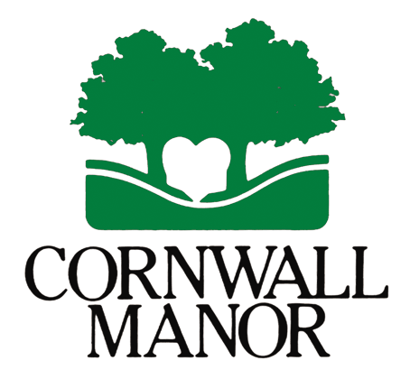
IRA TRANSFER FORM

Sample letter of instruction from donor to IRA Plan Provider

(Date)

(Name of Plan Provider)
(Address)
(City, State, Zip)

Re: Request for Direct Charitable Distribution from Individual Retirement Account

Dear Sir or Madam:

Please accept this letter as my request to make a direct charitable contribution from my Individual Retirement Account: (insert account number).

Please issue a check in the amount of $______________ payable to CORNWALL MANOR (a 501 (c) (3) charity, EIN 23-1365158 to the following address:

Cornwall Manor
Development Office
P.O. Box 125
Cornwall, PA 17016

In your transmittal to the charity, please state my name and address as the donor of record in connection with this transfer, and copy me on your transmittal. It is my intention to have this transfer quality during the ______ tax year.

If you have any questions or concerns regarding this request, I can be reached at (Phone and email address.)

Thank you for your prompt attention to and assistance with this matter.

Sincerely,

(Donor name)

Charitable News Update: IRA Rollover
An Early Christmas Present from Washington!

On December 18, Congress passed legislation, which the President signed, which extends the special IRA rollover, also known as “Qualified Charitable Distributions” permanent.
This gift treatment is available retroactively for any IRA gift since January 1, 2015.

For those aged 70 ½ or older, it is now possible to make tax-favored charitable gifts from both traditional and Roth IRA accounts. A total of up to $100,000 can be transferred directly from an IRA to one or more qualified charities such as CORNWALL MANOR free from federal income tax each year. There may also be state income tax savings. Amounts given in this way count toward required IRA minimum withdrawal amounts for the year of the gift.

To make such gifts, it is important to not withdraw funds prior to a gift, but instead have the gift amount distributed directly from an IRA to the qualified (501 (c) (3) charity. For those with check writing privileges on their accounts, this may be the most efficient way to make gifts directly from an IRA.

So what does this mean for YOU?

If you use the standard deduction for your taxes, this may be a gift option for you.

HOW? A simple letter will instruct your IRA administrator to transfer the amount you desire to the charity you specify. A sample letter is attached.

LIMITATION- You may NOT fund a charitable gift annuity, donor advised fund, a trust or a private foundation with IRA rollover gifts.

Your unique tax situation determines your benefits. Please consult your tax advisor before making this type of gift.

We are providing this information for you to consider for your gift and tax planning for 2015 and in future years.

Call Anne Peiffer in the Cornwall Manor Development Office (717-675-1511) to discuss.

Have a Merry Christmas!

